Goals for today’s meeting:

* Making the claw on the arm grasp onto mobile goals
* Making a clamp that can drag mobile goals
* Setup the Field Code Strip on the game field
* Testing the Inertia Sensor for the programming skills challenge and autonomous period using the Moby Robots
* Testing the GPS Sensor for the programming skills challenge using the Moby Robots
* Develop game strategies during the driver-controlled period
* Plan schedule & future meetings

Today, Andrew, Cyrus, and Kaitlyn attended the meeting. Our orders for the following products arrived:

* (1) V5 Inertial Sensor (276-4855)
* (1) V5 GPS Sensor (276-7405)
* (1) GPS Field Code Strip Set v2 (276-7823)

Andrew and Kaitlyn set up the GPS Field Code Strip, allowing us to use the GPS Sensor for the programming skills challenge.

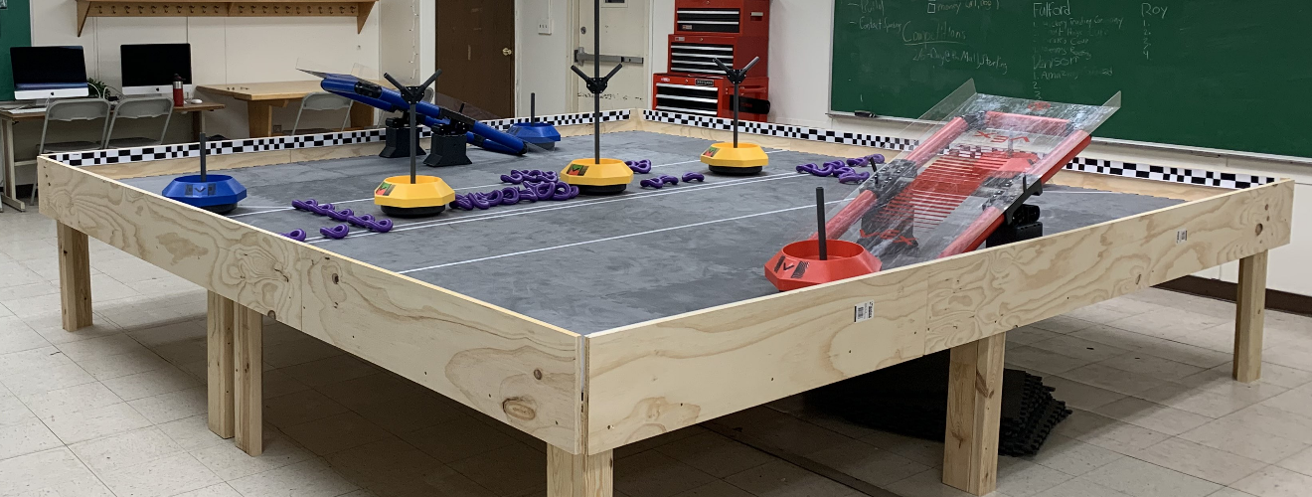

Testing the Solution: Cyrus added a claw to the arm, allowing the robot to use its arm to pick up a mobile goal. However, the arm could not support the weight of the single motor powering the arm. Therefore, he needed to add a second motor.

On another note, the game manual states that a robot can have at maximum, 8 motors. We plan on having 4 motors for the drivetrain, 2 motors for the arm, 1 motor for the claw for the arm, and 1 motor for the clamp. Only 1 motor is needed for the clamp because its primary function is to drag mobile goals and not pick up. The total amount is 8 motors.